RESTAURANTS&BARS

- Gloria (http://theglorycafe.com/) Turkish coffee bar in the city center
- Turkish House Restaurant (https://www.facebook.com/turkishhouselviv/) Traditional Turkish food
- Baczewski Restaurant (http://kumpelgroup.com/zaklady/baczewski/) - Baczewski Restaurant is a place that transfers the visitors into the merry Lviv in the beginning of the last century. Its goal is to promote local traditions and acquaint people with the history of the city and, of course, Galician cuisine.
- Beer Theatre “Pravda” (http://www.pravda.beer/) Beer Theatre “Pravda” is a place where the best world brewers are crafting unique brand of beers, bringing to Lviv their technology and skills. A unique Lviv beer brand is starting history.
- Kryivka - (https://www.fest.lviv.ua/uk/restaurants/kryjivka/) is the most extraordinary venue in Western Ukraine. Being located in a basement, it is designed after a shelter of the Ukrainian Insurgent Army fighters. Walls are decorated with military ammunition and portraits of soldiers. Guests sit on wooden furniture and eat Ukrainian dishes from metal tableware. Along with local foods, you can try traditional homemade drinks like horilka (water and purified alcohol) and alcoholic infusions of berries, honey and spices.
- Masoch Café – ( https://www.fest.lviv.ua/uk/restaurants/masochcafe/) Masoch is an exceptional place in Lviv that is dedicated to the man whose name is the origin of the word masochism. At the entrance to the venue, you will be greeted with a bronze monument of erotic writer Leopold von Sacher-Masoch.
- Drunk Cherry - Drunk Cherry, or Piyana Vyshnya, is a legendary bar in Lviv city. The door to the bar is always open, and you can recognize it by the huge red chandelier. There are only two items on the menu – a signature cake of the same name and a liqueur Vyshnivka (Cherry), which is often sought after by the tourists and locals alike.
- Stargorod – (http://www.stargorod.net/lv/ru/main) is a restaurant brewery in the city of Lviv. Only we brew the real Czech beer according to the classic technology on the best European equipment.
- 36 PO (http://www.36po.com.ua). Restaurant offers 5 floors of the exclusive surprises. The Ukrainian Food Art concept combines the culinary traditions and innovations. You'll surely be amazed by the variety of the Ukrainian cuisine, original recipes and excellent service. Are you ready for an emotional culinary acquaintance?

NIGHT CLUBS/ STRIP CLUBS
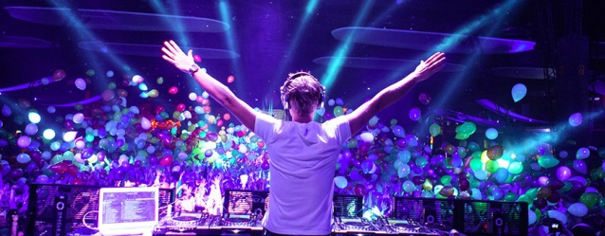
- Malevich night club (https://malevich-club.com/)
Entrance - 15€
- Rafinad People Club (https://www.rafinad-club.com/)
Entrance - 15€
- Split Club (http://www.split.lviv.ua/birahane-ve-restoran/)
Entrance - 15€ (Strip club)
- Cazanova Show bar ((http://cazanova.lviv.ua/?lang=eng)
Entrance - 15€ (Strip club)
- De Luxe (https://deluxecafe.lviv.ua/nightclub/)
Entrance - 15€
- Partyfon (http://www.partyfon.lviv.ua/)
Entrance - 15€

EXCURSIONS
Recommended excursions with Turkish - speaking guide
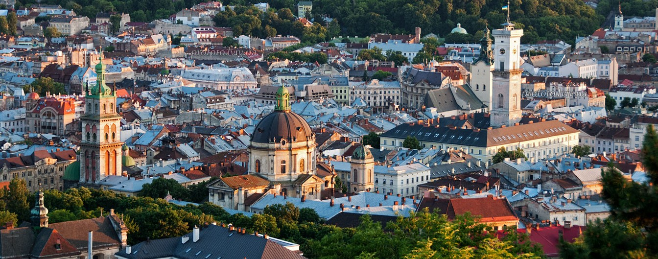
NAME OF EXCURSION | PRICE FOR 1 PERSON
 | 2 - 3 | 4 – 7 | 8 - 15 | 16 - 25
OLESKO CASTLE | - | - | 50€ | 35€
MYSTERY OF LVIV UNDERGROUNDS | 34€ | 22€ | 18€ | 14€
THE ROOFS OF LVIV | 29€ | 17€ | 13€ | 9€
NIGHT LVIV | 30€ | 18€ | 14€ | 10€
THE LEGENDS OF OLD LVIV | 28€ | 16€ | 12€ | 8€
COFFEE TOUR | 29€ | 17€ | 13€ | 9€
BEER TOUR | 29€ | 17€ | 13€ | 9€

